SCRIPT
INTRODUCTION
Hi everyone. Today I’m going to show you how to hand-knit using a thick yarn.
KNITTING
Starting Knot
First, you will start off by creating the first knot. You will make a circle with a yarn, and put it through the circle like this (video) and tighten it. There’s our first starting loop.
Adding Chains
After you have created the first starting knot, you want to add more loops so it has a base chain (foundation) of the project you’re planning on doing. For this video, I will create 7 more chains. You would place the first loop facing the side, and put the yarn through it, from the bottom to the top. Make as many chains as you want, until the last chain. For the last chain, make it look upwards instead of continuing to side.
Adding a Line of Chains
Since we created a solid foundation, it’s time to build up more rows on top of it. It’s pretty much the same as how you added the chains to the base chain, it’s just simpler. You will keep adding loops on top of it like this and repeat until you reach your desired length of your project.
Tying Off
To tie it off, there are two different ways of tying from what I know. Today, I will show you the one I think is simper. To start finishing off your knitting project, you will start by flipping the knitting over, and grab the first knot on the very far right, the one that’s on the opposite side of your last knot. Then you will put that over the second knot, and so it goes on. When you reach the last knot, you will put the string in and tighten it.
CONCLUDING
Today, I showed how to knit a simple blanket using a thick yarn and hands. I hope this video helped a lot, thank you for watching.

STORYBOARD
Narration:  (INTRODUCTION) Hi everyone. Today I’m going to show you …  Title Slide: None  Motion: None | 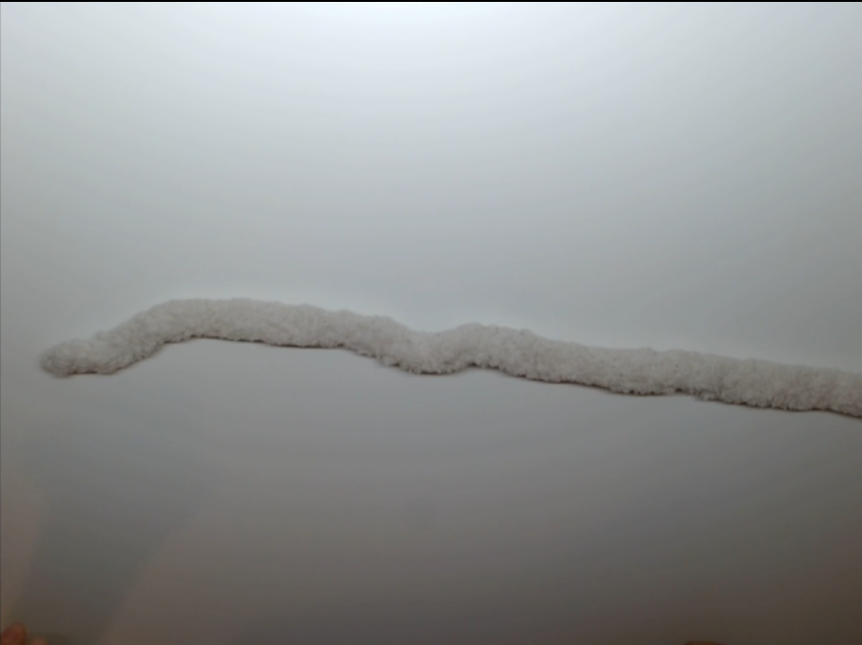
Narration:  (KNITTING - STARTING KNOT) First, you will start off by creating the first knot …  Title Slide: Creating a First Knot  Motion: Make a first knot | 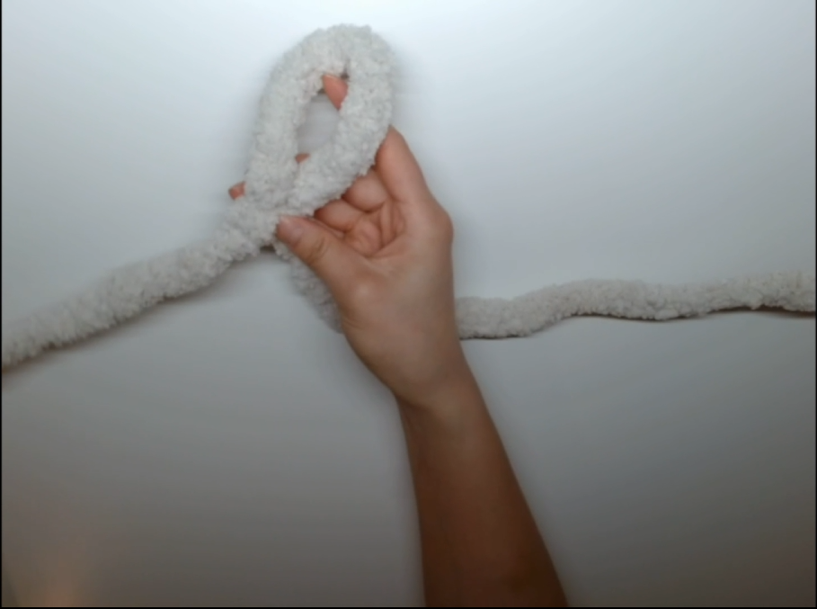
Narration:  (KNITTING - ADDING CHAINS) After you have created the first starting knot …  Title Slide: Adding Chains  Motion: Add chains | 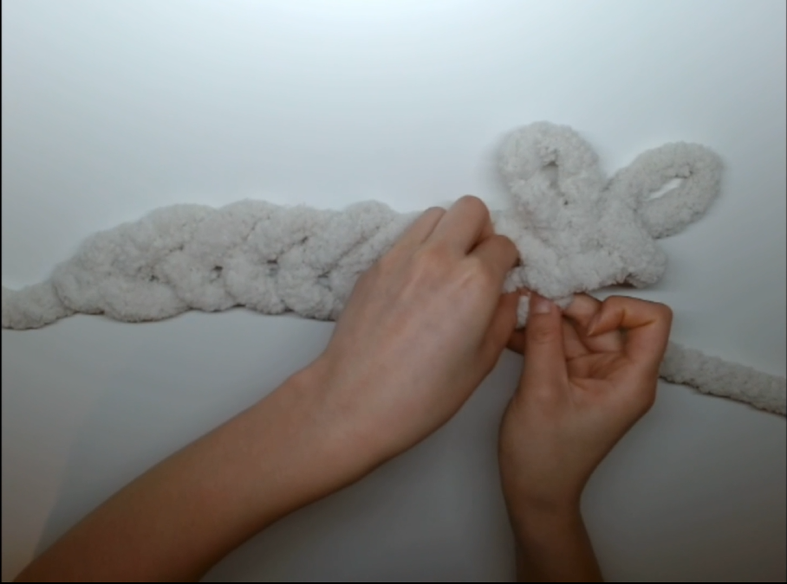
Narration:  (KNITTING - ADDING A LINE OF CHAINS) Since we created a solid foundation …  Title Slide: Adding a Row (Length)  Motion: Add a row on top. | 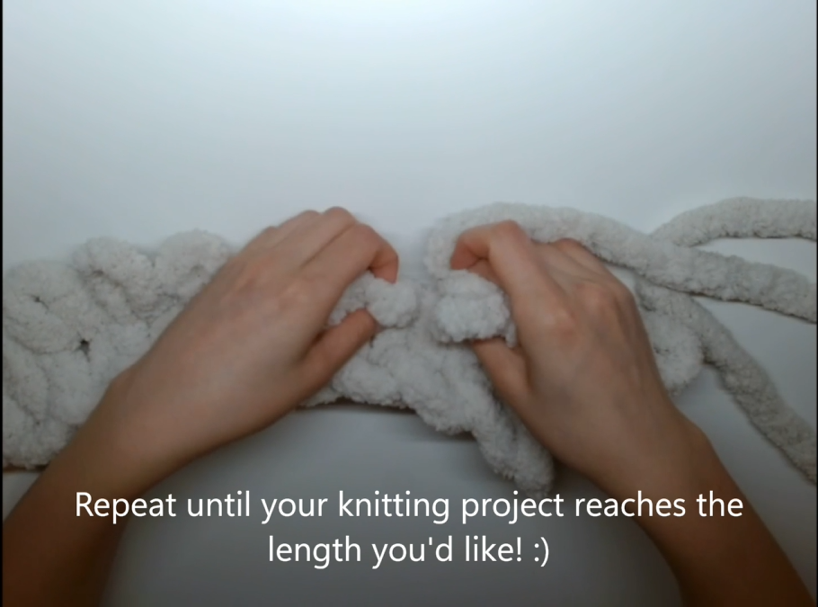
Narration:  (KNITTING – TYING OFF) To tie it off …  Title Slide: Tying (Finishing) Off  Motion: (create a few more rows on top and skip to this part before starting this) Finishing off the knitting | 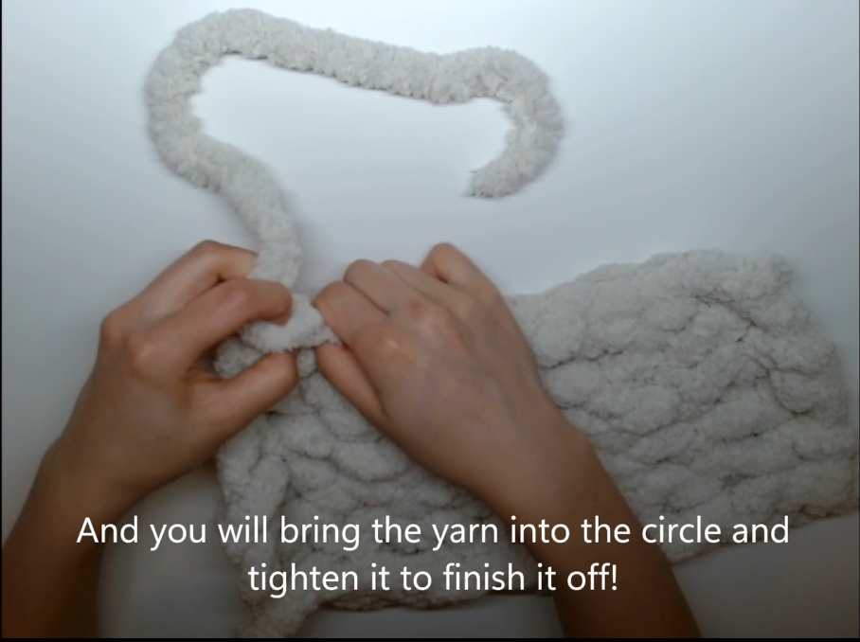
Narration:  (CONCLUDING) Today, I showed how …  Title Slide: None  Motion: None | 